FABRICATION MANUAL （Update 1）
1. File preparation
A dxf file named “DF_XXX.dxf” (XXX stands for the ID of the board) should be provided for each board. The content is illustrated here:
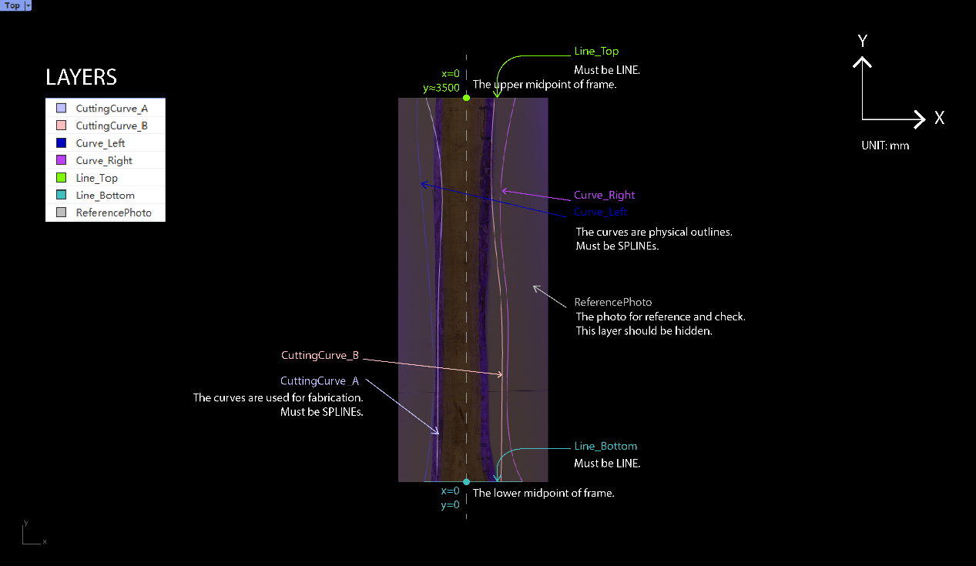
The exact content example without any illustration is shown here:
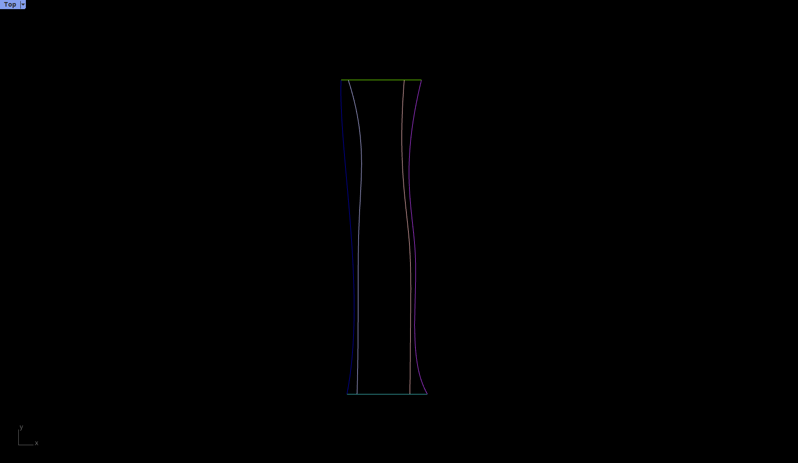
The example dxf file is attached.
2. Board preparation
Each board should be marked two section middle points, an arrow, and an ID before sent for fabrication. The arrow points to the origin point. The ID should be compatible with the digital file name.
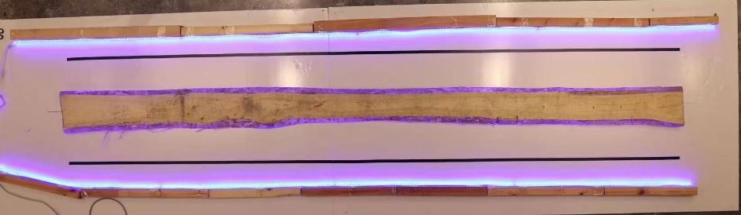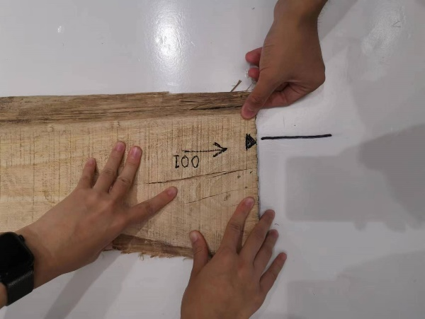
Triangle marker on the edge
Arrow pointing to the origin and ID
3. Board positioning
The coordinate system is drawn on the fabrication table illustrated in yellow. The origin point or the board should be overlapped to the origin point on the fabrication table. Then the other middle point should lie on the axis drawn.

4. Board fixing
Self-tapping screws are used to fix the boards. Each board needs three or more self-tapping screws that are non-colinear. The number of screws dependents on the flatness of the board.
5. Start milling
The fabrication team will do the milling.
6. Board removal
Remove the screws and remove the board.

